Perimeter Equality
# Source: AI Source: Provided by: [Data Path: Persons Table -> ID Column: 1, Name_En Column: Motasem Essam] -> From: [ChatGPT] on [7/25/2026]
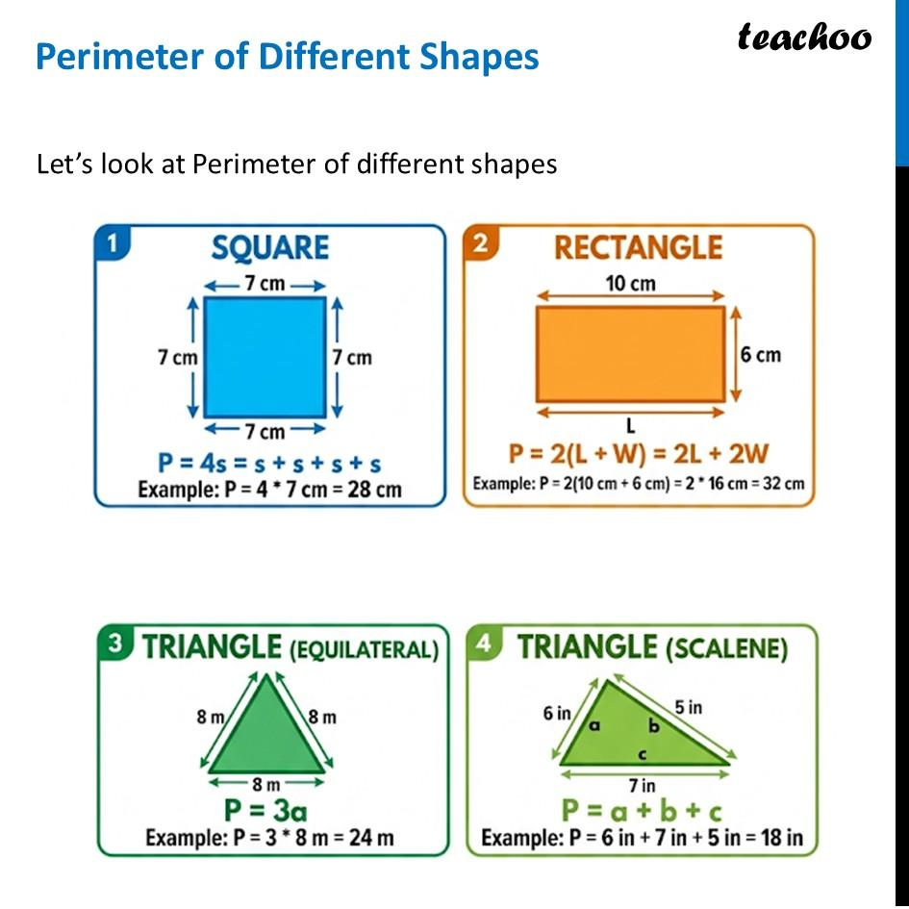
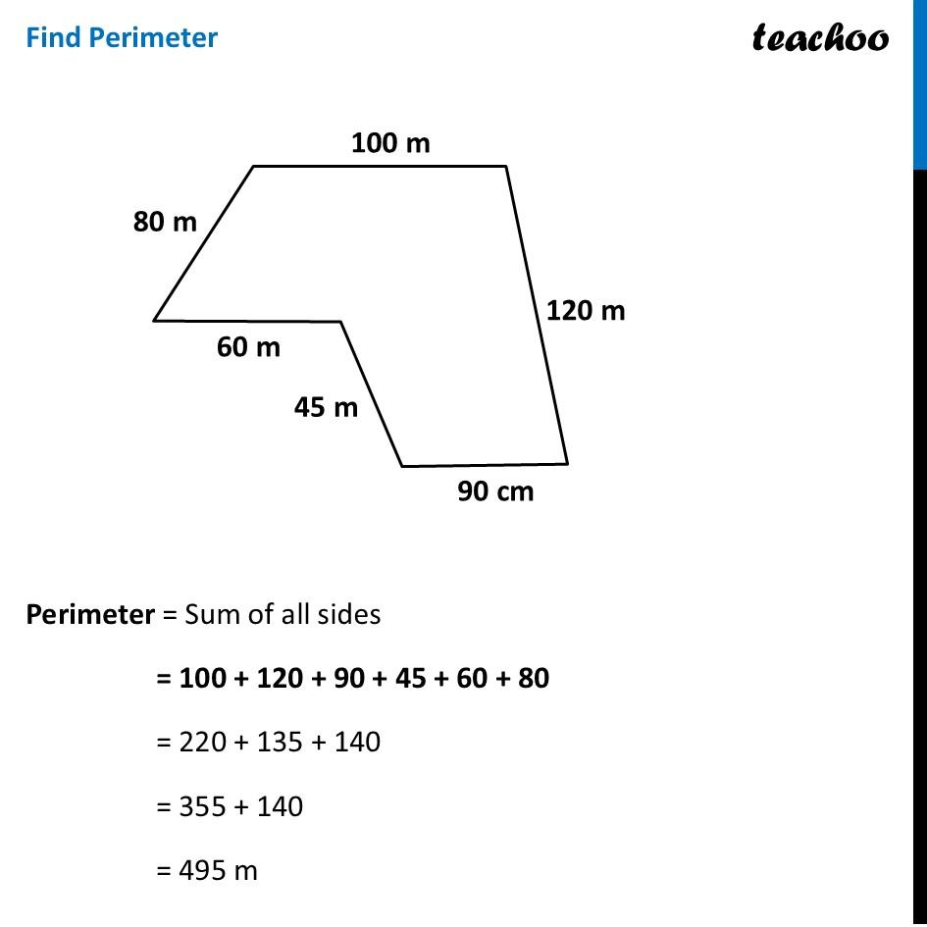
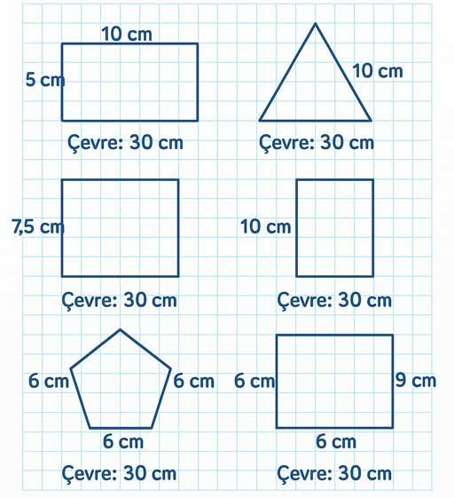
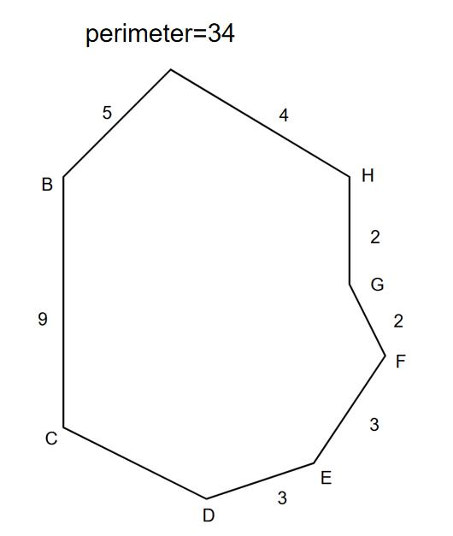
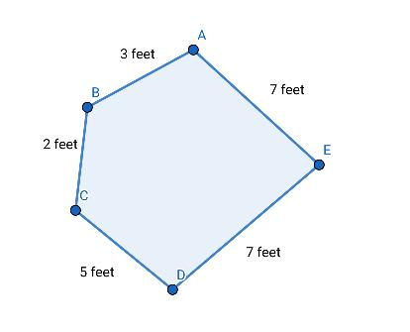

Definition
# Source: AI Source: Provided by: [Data Path: Persons Table -> ID Column: 1, Name_En Column: Motasem Essam] -> From: [ChatGPT] on [7/25/2026]
Perimeter Equality is an exact geometric relationship in which two or more closed two-dimensional figures have the same total boundary length.
$$\boxed{P_{1}=P_{2}}$$
where $P_{1}$and $P_{2}$are the perimeters of two figures.
For a polygon, the perimeter is the sum of the lengths of all its sides:
$$\boxed{P=s_{1}+s_{2}+⋯+s_{n}}$$

Simple Definition
# Source: AI Source: Provided by: [Data Path: Persons Table -> ID Column: 1, Name_En Column: Motasem Essam] -> From: [ChatGPT] on [7/25/2026]
Perimeter Equality means that two or more geometric figures have exactly the same total boundary length, even if their shapes, side lengths, or areas are different.
For example:
- Rectangle: $6×4$
$$P=2\left(6+4\right)=20$$
- Square: side $5$
$$P=4\left(5\right)=20$$
Therefore,
$$\boxed{P_{\text{rectangle}}=P_{\text{square}}=20}$$
although the two figures have different shapes and areas.

Fundamental Concept
# Source: AI Source: Provided by: [Data Path: Persons Table -> ID Column: 1, Name_En Column: Motasem Essam] -> From: [ChatGPT] on [7/25/2026]
Perimeter equality compares the total length around the boundary of figures.
$$\boxed{\text{Perimeter Equality}=\text{Equal Total Boundary Length}}$$
It does not require:
- the same shape,
- the same side lengths,
- the same number of sides,
- the same area,
- or congruence.
For example:
$$\boxed{P_{1}=P_{2}}$$
does not necessarily mean:
$$A_{1}=A_{2}$$
and does not necessarily mean:
$$F_{1}≅F_{2}.$$

Classification of Perimeter Equality
# Source: AI Source: Provided by: [Data Path: Persons Table -> ID Column: 1, Name_En Column: Motasem Essam] -> From: [ChatGPT] on [7/25/2026]
A practical classification is:
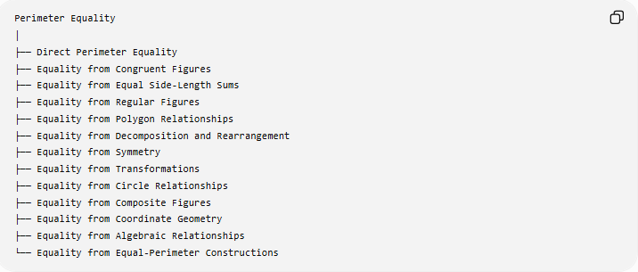
Perimeter Equality
│
├── Direct Perimeter Equality
├── Equality from Congruent Figures
├── Equality from Equal Side-Length Sums
├── Equality from Regular Figures
├── Equality from Polygon Relationships
├── Equality from Decomposition and Rearrangement
├── Equality from Symmetry
├── Equality from Transformations
├── Equality from Circle Relationships
├── Equality from Composite Figures
├── Equality from Coordinate Geometry
├── Equality from Algebraic Relationships
└── Equality from Equal-Perimeter Constructions
This is a practical classification, rather than a universally standardized list of formal mathematical types.

Direct Perimeter Equality
# Source: AI Source: Provided by: [Data Path: Persons Table -> ID Column: 1, Name_En Column: Motasem Essam] -> From: [ChatGPT] on [7/25/2026]
Definition
The perimeter equality is given directly:
$$\boxed{P_{1}=P_{2}}$$
Example
Suppose:
$$P_{1}=30\text{ cm}$$
and
$$P_{2}=30\text{ cm}.$$
Then:
$$\boxed{P_{1}=P_{2}}$$
Example with polygons
A triangle has sides:
$$8, 10, 12$$
so:
$$P=8+10+12=30.$$
A rectangle has dimensions:
$$10×5$$
so:
$$P=2\left(10+5\right)=30.$$
Therefore:
$$\boxed{P_{△}=P_{\text{rectangle}}=30}$$
even though the figures are different.

Perimeter Equality from Congruent Figures
# Source: AI Source: Provided by: [Data Path: Persons Table -> ID Column: 1, Name_En Column: Motasem Essam] -> From: [ChatGPT] on [7/25/2026]
Definition
Congruent figures have the same shape and size. Therefore, their corresponding side lengths are equal, which guarantees equal perimeters.
$$\boxed{F_{1}≅F_{2}⇒P_{1}=P_{2}}$$
Example
If:
$$△ABC≅△DEF$$
then:
$$AB=DE, BC=EF, AC=DF.$$
Therefore:
$$AB+BC+AC=DE+EF+DF$$
and hence:
$$\boxed{P_{ABC}=P_{DEF}}.$$
Important
The converse is not generally true:
$$\boxed{P_{1}=P_{2}⇏F_{1}≅F_{2}}$$
Two non-congruent figures can have the same perimeter.

Equality from Equal Side-Length Sums
# Source: AI Source: Provided by: [Data Path: Persons Table -> ID Column: 1, Name_En Column: Motasem Essam] -> From: [ChatGPT] on [7/25/2026]
Definition
Two polygons have equal perimeters when the sums of their side lengths are equal.
$$\boxed{s_{1}+s_{2}+⋯+s_{n}=t_{1}+t_{2}+⋯+t_{m}}$$
Example
Polygon A:
$$5+7+8+10=30$$
Polygon B:
$$6+6+9+9=30$$
Therefore:
$$\boxed{P_{A}=P_{B}=30}$$
The individual side lengths are different, but their totals are equal.

Perimeter Equality in Regular Figures
# Source: AI Source: Provided by: [Data Path: Persons Table -> ID Column: 1, Name_En Column: Motasem Essam] -> From: [ChatGPT] on [7/25/2026]
Definition
For a regular polygon with $n$equal sides of length $s$:
$$\boxed{P=ns}$$
Therefore, two regular polygons have equal perimeters when:
$$\boxed{n_{1}s_{1}=n_{2}s_{2}}$$
Example
A square with side $6$:
$$P=4\left(6\right)=24.$$
A regular hexagon with side $4$:
$$P=6\left(4\right)=24.$$
Therefore:
$$\boxed{P_{\text{square}}=P_{\text{hexagon}}=24}$$
although they have different numbers of sides.

Perimeter Equality in Rectangles
# Source: AI Source: Provided by: [Data Path: Persons Table -> ID Column: 1, Name_En Column: Motasem Essam] -> From: [ChatGPT] on [7/25/2026]
For a rectangle:
$$\boxed{P=2\left(l+w\right)}$$
Therefore, two rectangles have equal perimeters if:
$$\boxed{l_{1}+w_{1}=l_{2}+w_{2}}$$
Example
Rectangle A:
$$l=8, w=5 \\ P_{A}=2\left(8+5\right)=26.$$
Rectangle B:
$$l=10, w=3 \\ P_{B}=2\left(10+3\right)=26.$$
Thus:
$$\boxed{P_{A}=P_{B}=26}$$
But their areas are:
$$A_{A}=8\left(5\right)=40$$
and
$$A_{B}=10\left(3\right)=30.$$
So:
$$\boxed{P_{A}=P_{B} \text{but} A_{A}≠A_{B}}$$

Perimeter Equality in Squares
# Source: AI Source: Provided by: [Data Path: Persons Table -> ID Column: 1, Name_En Column: Motasem Essam] -> From: [ChatGPT] on [7/25/2026]
For a square:
$$\boxed{P=4s}$$
If two squares have equal perimeters:
$$4s_{1}=4s_{2}$$
so:
$$\boxed{s_{1}=s_{2}}$$
Example
Square A:
$$s=7 \\ P=28.$$
If Square B also has perimeter $28$:
$$4s=28 \\ s=7.$$
Therefore, the two squares have equal side lengths.

Perimeter Equality from Decomposition
# Source: AI Source: Provided by: [Data Path: Persons Table -> ID Column: 1, Name_En Column: Motasem Essam] -> From: [ChatGPT] on [7/25/2026]
Definition
A complex figure can be divided into simpler components. If two figures have boundaries with the same total length, their perimeters can be shown to be equal.
Example
Suppose a composite figure has boundary segments:
$$4+6+3+5+2+10.$$
Then:
$$P=30.$$
Another figure has boundary:
$$8+7+5+10.$$
Then:
$$P=30.$$
Therefore:
$$\boxed{P_{1}=P_{2}}.$$
Important distinction
When decomposing a figure, internal edges are not part of the perimeter unless they lie on the outside boundary.

Perimeter Equality from Rearrangement
# Source: AI Source: Provided by: [Data Path: Persons Table -> ID Column: 1, Name_En Column: Motasem Essam] -> From: [ChatGPT] on [7/25/2026]
Rearranging pieces can sometimes preserve the total outer boundary length.
For example, if several pieces are rearranged without changing the lengths of the exposed boundary segments, the resulting figures can have equal perimeters.
However:
$$\boxed{\text{Equal area does not automatically mean equal perimeter}}$$
and rearrangement can change the amount of boundary exposed.
Therefore, perimeter must be calculated from the actual final outer boundary.

Perimeter Equality from Symmetry
# Source: AI Source: Provided by: [Data Path: Persons Table -> ID Column: 1, Name_En Column: Motasem Essam] -> From: [ChatGPT] on [7/25/2026]
Symmetry can create equal boundary portions.
For example, a figure symmetric about a vertical axis may have:
$$AB=CD$$
and:
$$BC=DA.$$
Thus:
$$AB+BC+CD+DA=2AB+2BC.$$
Example
A rectangle has:
$$AB=CD=8$$
and:
$$BC=DA=5.$$
Therefore:
$$P=8+5+8+5=26.$$
Symmetry makes the calculation easier by pairing equal sides.

Perimeter Equality from Transformations
# Source: AI Source: Provided by: [Data Path: Persons Table -> ID Column: 1, Name_En Column: Motasem Essam] -> From: [ChatGPT] on [7/25/2026]
Some transformations preserve lengths and therefore preserve perimeter.
Isometries
The following transformations preserve distances:
- Translation
- Rotation
- Reflection
- Glide reflection
Therefore:
$$\boxed{\text{Isometry}⇒\text{Perimeter Preservation}}$$
If a figure $F$is transformed into $F^{'}$by an isometry:
$$\boxed{P_{F}=P_{F^{'}}}$$
Example
A triangle has sides:
$$5, 7, 8.$$
After a rotation, its corresponding sides remain:
$$5, 7, 8.$$
Therefore:
$$P=20$$
before and after the rotation.

Perimeter Equality and Scaling
# Source: AI Source: Provided by: [Data Path: Persons Table -> ID Column: 1, Name_En Column: Motasem Essam] -> From: [ChatGPT] on [7/25/2026]
Scaling is different from an isometry.
If every length is multiplied by a scale factor $k$, the perimeter is also multiplied by $k$:
$$\boxed{P^{'}=kP}$$
Therefore, similar figures have equal perimeters only when:
$$\boxed{k=1}$$
for ordinary positive scale factors.
Example
A triangle has perimeter:
$$P=20.$$
A similar triangle is enlarged by:
$$k=2.$$
Then:
$$P^{'}=2\left(20\right)=40.$$
So:
$$P^{'}≠P.$$
This differs from area scaling:
$$A^{'}=k^{2}A.$$

Perimeter Equality in Circles
# Source: AI Source: Provided by: [Data Path: Persons Table -> ID Column: 1, Name_En Column: Motasem Essam] -> From: [ChatGPT] on [7/25/2026]
For a circle, the boundary length is called circumference:
$$\boxed{C=2πr}$$
Therefore, two circles have equal circumferences when:
$$2πr_{1}=2πr_{2}.$$
Hence:
$$\boxed{r_{1}=r_{2}}$$
Example
Circle A:
$$r=5 \\ C=10π.$$
Circle B:
$$r=5 \\ C=10π.$$
Therefore:
$$\boxed{C_{A}=C_{B}}.$$
Important terminology
For polygons, we normally say perimeter.
For a circle, we normally say circumference.
But circumference can be viewed as the boundary length analogous to perimeter.

Perimeter Equality for Circular Figures
# Source: AI Source: Provided by: [Data Path: Persons Table -> ID Column: 1, Name_En Column: Motasem Essam] -> From: [ChatGPT] on [7/25/2026]
For a circular sector, the boundary includes:
- two radii,
- one circular arc.
Thus:
$$\boxed{P=2r+rθ}$$
when $θ$is measured in radians.
For a semicircle:
$$\boxed{P=πr+2r}$$
including the diameter.
Example
For $r=4$:
$$P=π\left(4\right)+8 \\ \boxed{P=4π+8}.$$

Perimeter Equality of Composite Figures
# Source: AI Source: Provided by: [Data Path: Persons Table -> ID Column: 1, Name_En Column: Motasem Essam] -> From: [ChatGPT] on [7/25/2026]
Definition
A composite figure consists of multiple geometric parts. Its perimeter is found by adding only the lengths of the external boundary.
Example
Suppose a figure consists of a rectangle with a semicircle attached to one side.
The perimeter includes:
- the exposed rectangle sides,
- the semicircular arc,
but not the shared diameter between the rectangle and semicircle.
If the exposed straight portions total $18$and the semicircle has radius $4$:
$$P=18+π\left(4\right) \\ \boxed{P=18+4π}.$$

Perimeter Equality from Coordinate Geometry
# Source: AI Source: Provided by: [Data Path: Persons Table -> ID Column: 1, Name_En Column: Motasem Essam] -> From: [ChatGPT] on [7/25/2026]
For a polygon with vertices:
$$\left(x_{1} , y_{1}\right),\left(x_{2} , y_{2}\right),…,\left(x_{n} , y_{n}\right),$$
each side can be calculated using the distance formula:
$$\boxed{d=\sqrt{{\left(x_{2}-x_{1}\right)}^{2}+{\left(y_{2}-y_{1}\right)}^{2}}}$$
Then:
$$\boxed{P=d_{1}+d_{2}+⋯+d_{n}}.$$
Example
Consider a square:
$$A=\left(0 , 0\right), B=\left(3 , 0\right), C=\left(3 , 3\right), D=\left(0 , 3\right).$$
Each side has length:
$$3.$$
Therefore:
$$P=3+3+3+3=12.$$

Perimeter Equality Established Algebraically
# Source: AI Source: Provided by: [Data Path: Persons Table -> ID Column: 1, Name_En Column: Motasem Essam] -> From: [ChatGPT] on [7/25/2026]
Perimeters can be expressed using algebraic variables.
Example
Suppose:
$$P_{1}=3x+10$$
and:
$$P_{2}=5x-6.$$
For equal perimeters:
$$3x+10=5x-6.$$
Therefore:
$$16=2x \\ x=8.$$
Substituting:
$$P_{1}=3\left(8\right)+10=34$$
and:
$$P_{2}=5\left(8\right)-6=34.$$
Thus:
$$\boxed{P_{1}=P_{2}=34}.$$

Equal Perimeter Does Not Mean Equal Area
This is one of the most important distinctions.
Two figures can have:
$$\boxed{P_{1}=P_{2}}$$
while:
$$\boxed{A_{1}≠A_{2}}.$$
Example
Rectangle A:
$$8×5 \\ P_{A}=26, A_{A}=40.$$
Rectangle B:
$$10×3 \\ P_{B}=26, A_{B}=30.$$
Therefore:
$$\boxed{P_{A}=P_{B}}$$
but:
$$\boxed{A_{A}≠A_{B}}.$$

Equal Perimeter Does Not Mean Congruence
# Source: AI Source: Provided by: [Data Path: Persons Table -> ID Column: 1, Name_En Column: Motasem Essam] -> From: [ChatGPT] on [7/25/2026]
Equal perimeter does not guarantee that two figures have the same shape and size.
$$\boxed{P_{1}=P_{2}⇏F_{1}≅F_{2}}$$
For example:
- Square: $6×6$
$$P=24$$
- Rectangle: $8×4$
$$P=24$$
They have equal perimeters but are not congruent.

Equal Perimeter Does Not Mean Equal Side Lengths
# Source: AI Source: Provided by: [Data Path: Persons Table -> ID Column: 1, Name_En Column: Motasem Essam] -> From: [ChatGPT] on [7/25/2026]
Consider two quadrilaterals.
Figure A:
$$5,5,7,7$$
Figure B:
$$4,6,8,6$$
Both have:
$$P=24.$$
But their corresponding side lengths are not equal.
Therefore:
$$\boxed{\text{Equal perimeter}⇏\text{equal corresponding sides}}$$

Perimeter Equality vs Area Equality
# Source: AI Source: Provided by: [Data Path: Persons Table -> ID Column: 1, Name_En Column: Motasem Essam] -> From: [ChatGPT] on [7/25/2026]
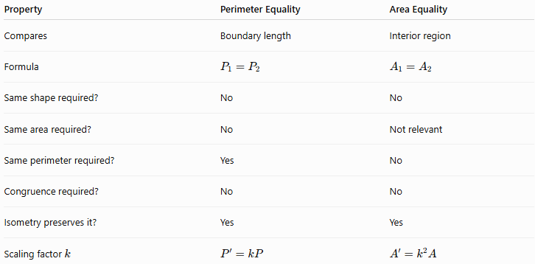
Property | Perimeter Equality | Area Equality
Compares | Boundary length | Interior region
Formula | $$P_{1}=P_{2}$$ | $$A_{1}=A_{2}$$
Same shape required? | No | No
Same area required? | No | Not relevant
Same perimeter required? | Yes | No
Congruence required? | No | No
Isometry preserves it? | Yes | Yes
Scaling factor $k$ | $$P^{'}=kP$$ | $$A^{'}=k^{2}A$$
Thus:
$$\boxed{\text{Perimeter Equality}≠\text{Area Equality}}$$

Perimeter Equality vs Congruence
# Source: AI Source: Provided by: [Data Path: Persons Table -> ID Column: 1, Name_En Column: Motasem Essam] -> From: [ChatGPT] on [7/25/2026]
Perimeter Equality
$$\boxed{P_{1}=P_{2}}$$
Only the total boundary lengths are equal.
Congruence
$$\boxed{F_{1}≅F_{2}}$$
The figures have the same shape and size.
Therefore:
$$\boxed{\text{Congruence}⇒\text{Perimeter Equality}}$$
but generally:
$$\boxed{\text{Perimeter Equality}⇏\text{Congruence}}.$$

Important Perimeter Formulas
# Source: AI Source: Provided by: [Data Path: Persons Table -> ID Column: 1, Name_En Column: Motasem Essam] -> From: [ChatGPT] on [7/25/2026]
Polygon
$$\boxed{P=s_{1}+s_{2}+⋯+s_{n}}$$
Equilateral Triangle
$$\boxed{P=3s}$$
Square
$$\boxed{P=4s}$$
Rectangle
$$\boxed{P=2\left(l+w\right)}$$
Parallelogram
$$\boxed{P=2\left(a+b\right)}$$
Rhombus
$$\boxed{P=4s}$$
Regular Polygon
$$\boxed{P=ns}$$
Circle
$$\boxed{C=2πr=πd}$$
Semicircle including diameter
$$\boxed{P=πr+2r}$$
Circular Sector
$$\boxed{P=2r+rθ}$$
where $θ$is in radians.

Equality of Perimeters Under Isometry
# Source: AI Source: Provided by: [Data Path: Persons Table -> ID Column: 1, Name_En Column: Motasem Essam] -> From: [ChatGPT] on [7/25/2026]
An important general principle is:
$$\boxed{\text{Isometry}⇒\text{Equal Corresponding Lengths}⇒\text{Equal Perimeters}}$$
Therefore:
$$\boxed{P\left(F\right)=P\left(T\left(F\right)\right)}$$
for an isometric transformation $T$.
This applies to:
- translation,
- rotation,
- reflection,
- glide reflection.

Perimeter Optimization
# Source: AI Source: Provided by: [Data Path: Persons Table -> ID Column: 1, Name_En Column: Motasem Essam] -> From: [ChatGPT] on [7/25/2026]
Perimeter equality is also important in optimization problems.
For rectangles:
$$P=2\left(l+w\right).$$
If the perimeter is fixed:
$$l+w=\frac{P}{2}.$$
Different rectangles can therefore have the same perimeter but different areas.
For a fixed perimeter, the square has the greatest area among rectangles.
For a broader class of plane figures, the isoperimetric inequality states:
$$\boxed{4πA≤P^{2}}$$
with equality for a circle.
This connects perimeter equality with area optimization.

Perimeter Equality in Geometric Proofs
# Source: AI Source: Provided by: [Data Path: Persons Table -> ID Column: 1, Name_En Column: Motasem Essam] -> From: [ChatGPT] on [7/25/2026]
Perimeter equality can be the conclusion of a proof.
Example
Suppose two quadrilaterals have corresponding side equalities:
$$AB=EF \\ BC=FG \\ CD=GH \\ DA=HE.$$
Then:
$$AB+BC+CD+DA=EF+FG+GH+HE.$$
Therefore:
$$\boxed{P_{ABCD}=P_{EFGH}}.$$
This is a direct proof of perimeter equality.

Classification Summary
# Source: AI Source: Provided by: [Data Path: Persons Table -> ID Column: 1, Name_En Column: Motasem Essam] -> From: [ChatGPT] on [7/25/2026]
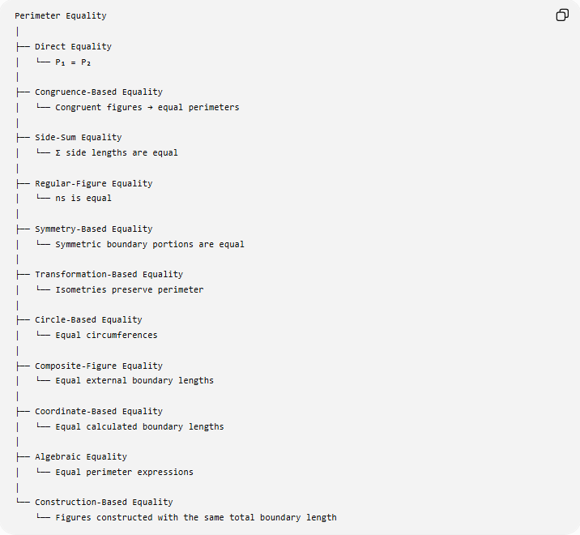
Perimeter Equality
│
├── Direct Equality
│ └── P₁ = P₂
│
├── Congruence-Based Equality
│ └── Congruent figures → equal perimeters
│
├── Side-Sum Equality
│ └── Σ side lengths are equal
│
├── Regular-Figure Equality
│ └── ns is equal
│
├── Symmetry-Based Equality
│ └── Symmetric boundary portions are equal
│
├── Transformation-Based Equality
│ └── Isometries preserve perimeter
│
├── Circle-Based Equality
│ └── Equal circumferences
│
├── Composite-Figure Equality
│ └── Equal external boundary lengths
│
├── Coordinate-Based Equality
│ └── Equal calculated boundary lengths
│
├── Algebraic Equality
│ └── Equal perimeter expressions
│
└── Construction-Based Equality
└── Figures constructed with the same total boundary length

Relationship to Geometric Equality
# Source: AI Source: Provided by: [Data Path: Persons Table -> ID Column: 1, Name_En Column: Motasem Essam] -> From: [ChatGPT] on [7/25/2026]
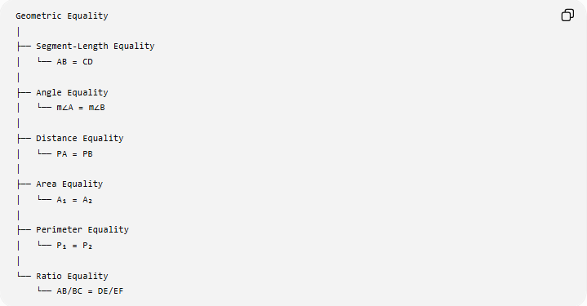
Geometric Equality
│
├── Segment-Length Equality
│ └── AB = CD
│
├── Angle Equality
│ └── m∠A = m∠B
│
├── Distance Equality
│ └── PA = PB
│
├── Area Equality
│ └── A₁ = A₂
│
├── Perimeter Equality
│ └── P₁ = P₂
│
└── Ratio Equality
└── AB/BC = DE/EF
Perimeter Equality therefore belongs to the broader family of Geometric Equality, but it specifically compares total boundary lengths.

Key Points
# Source: AI Source: Provided by: [Data Path: Persons Table -> ID Column: 1, Name_En Column: Motasem Essam] -> From: [ChatGPT] on [7/25/2026]
- Perimeter Equality means:
$$\boxed{P_{1}=P_{2}}$$
- It compares the total boundary length of figures.
- Different shapes can have equal perimeters.
- Equal perimeters do not imply equal areas.
- Equal perimeters do not imply congruence.
- Congruent figures always have equal perimeters:
$$\boxed{F_{1}≅F_{2}⇒P_{1}=P_{2}}$$
- Isometries preserve perimeter.
- Scaling changes perimeter according to:
$$\boxed{P^{'}=kP}$$
- For a regular polygon:
$$\boxed{P=ns}$$
- For a rectangle:
$$\boxed{P=2\left(l+w\right)}$$
- For a circle, the corresponding boundary measure is circumference:
$$\boxed{C=2πr}$$
- Composite-figure perimeter calculations include only the external boundary.
- Perimeter equality can be established through geometry, algebra, coordinates, symmetry, congruence, transformations, or direct calculation.

Conclusion
# Source: AI Source: Provided by: [Data Path: Persons Table -> ID Column: 1, Name_En Column: Motasem Essam] -> From: [ChatGPT] on [7/25/2026]
Perimeter Equality is the exact equality of the total boundary lengths of two or more geometric figures:
$$\boxed{P_{1}=P_{2}}$$
It is an important form of Geometric Equality because it allows figures with different shapes, side lengths, and areas to be compared through their boundary lengths. Congruence and isometric transformations guarantee perimeter equality, while equal perimeter alone does not guarantee congruence or equal area.
$$\boxed{\text{Perimeter Equality}=\text{Equal Total Boundary Length}}$$

